Oracle Database Administration
Oracle User Creation and Admin Right for L1 and L2 Engineer at OS level in Windows

Submitted to



By



CIS, Wipro Limited

Document Details

Project Name | Innogy SE
Account | CIS
IT Component/Application Title | Oracle User Creation and Admin Right for L1 and L2 Engineer at OS level in Windows
Current Version | 1.5
List of Contributors | Chetan Patel , Kamlesh Sawant , Jiten Pansara , Abhishek Kansal, Saurabh Nigam, Sreya Puthukudy
Customer Contact Information

Version History
(All revisions made to this document must be listed in chronological order. All revisions must be approved. Review and Approval can be done by an internal source or by the customer)
Version | Date of Revision | Description | Author | Reviewed By | Approved By
1.0 | 29-08-2015 | Intial Draft | Chetan Patel | Chetan Patel | Mihir Gajjar
1.1 | 04-09-2015 | Document Completed | Chetan Patel | Chetan Patel | Mihir Gajjar
1.2 | 21-08-2016 | Updated document to standard format | Kamlesh Sawant | Saurabh Nigam | Mahesh Keshatwar
1.3 | 17-05-2017 | Wipro and Innogy Logo changed | Abhishek Kansal | Jiten Pansara | Mahesh Keshatwar
1.4 | 24-10-2017 | Updated document to Wipro Standard format with header and footer | Abhishek Kansal | Jiten Pansara | Mahesh Keshatwar
1.5 | 24-12-2018 | Updated the content | Sreya Puthukudy | Jiten Pansara | Santosh Badiger

Document Distribution List
Sl. No. | Name and Company | Purpose
1 | RWEIT-ORACLEDBA | This document regarding Oracle User Creation and Admin Right for L1 and L2 Engineer at OS level in Windows
2

TABLE OF CONTENT
1. Purpose 1
2. Scope 1
3. Privileges 1
4. L1 User Creation 1
5. L2 User Creation 5

Purpose
This document is prepared for creating User Creation and Admin Rights for L1 & L2 Engineer at OS Level for MIT team at Oracle database at RWE GBS UK location.

Scope
This document provides the work instruction for the User creation for L1 & L2 Engineer at OS Level for MIT team at.

Privileges
Domain | Level | Privileges
Oracle | L1 | 1) User with RDP/Net Meeting privilege  2) User
Oracle | L2 | 1) User with RDP/Net Meeting privilege  2) Local admin access

L1 User Creation
Step 1: Logon to DB Server

Go to START ->RUN -> MSTSC
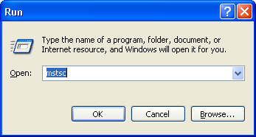

Step 2: Give the IP and press enter

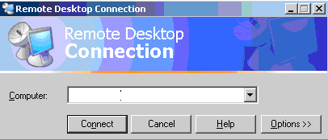

Step 3: Login with Group id and Right click on My Computer and select manage.
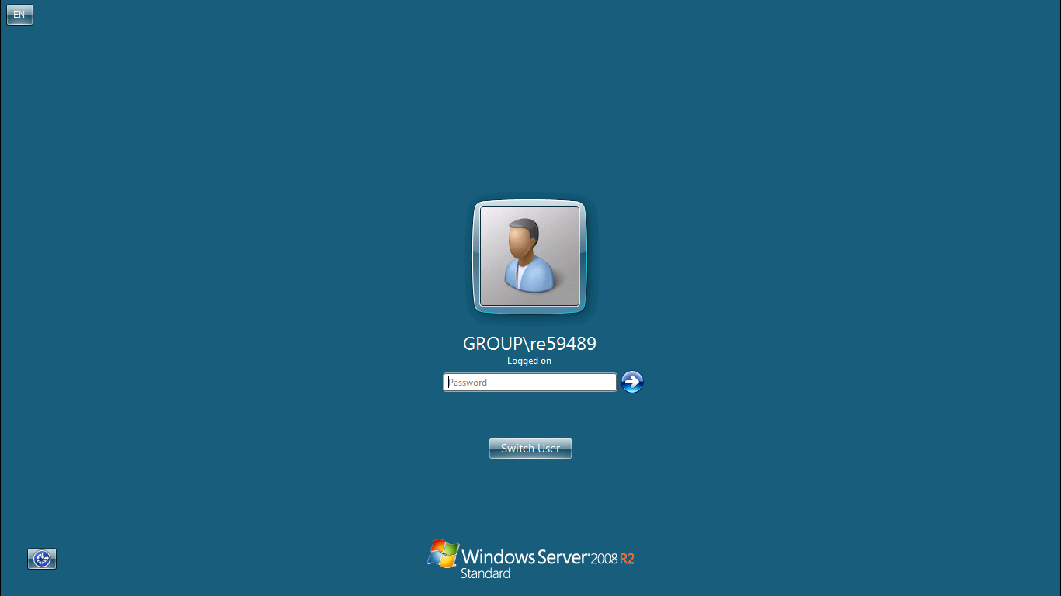

Step 4: Expand the Local Users and Groups
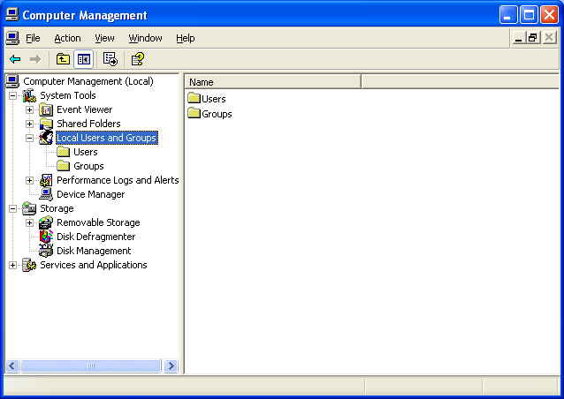
Step 5: Right click on Group and select ORA_DBA group and add group id.
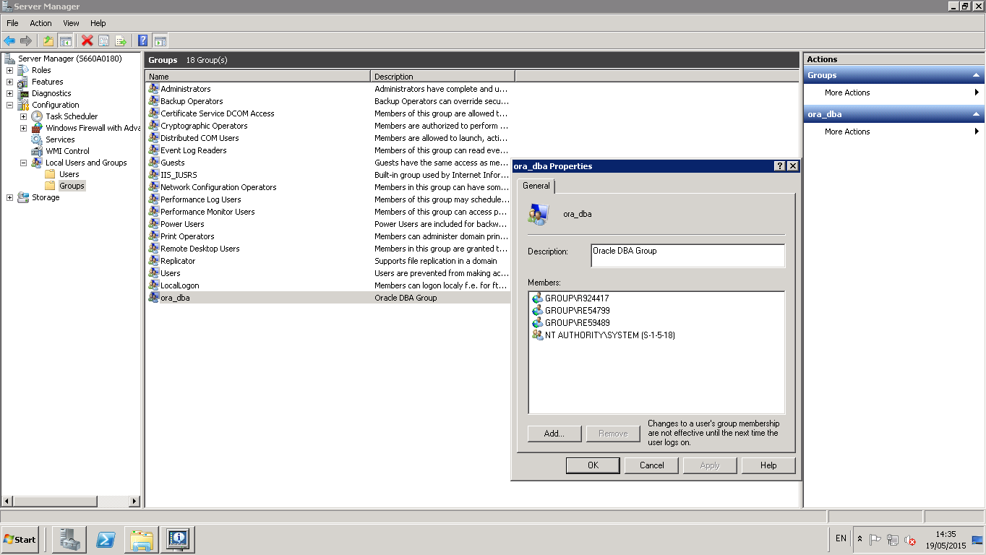

Step 6: Specify the below details.
Username: Name of the user with GROUP domin.
Full Name: Full name of user. This is optional
Description: Description of the user creation purpose.
Password: Password for User
Confirm Password: Re-enter the password.

L2 User Creation
Steps will remain same for L2 level privileges. Please follow same steps as L1 level.

